ESM2 Figures
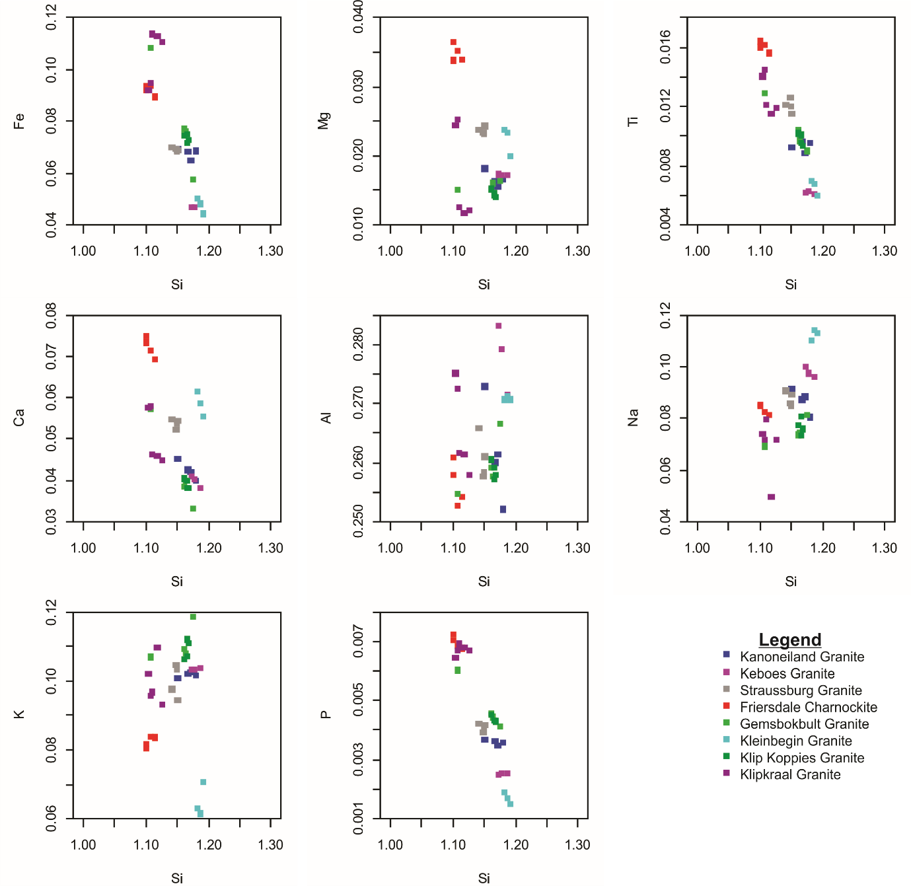
Figure S1. Harker plots for the Keimoes Suite granitoids.

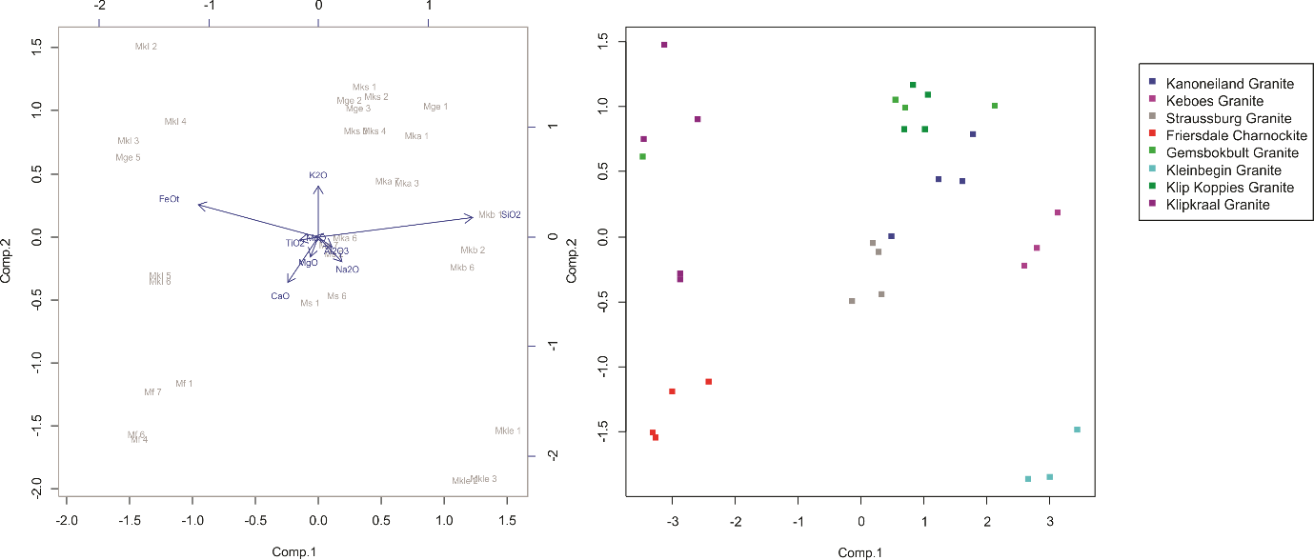
Figure S2. Principal component analysis (PCA) plots for the Keimoes Suite.

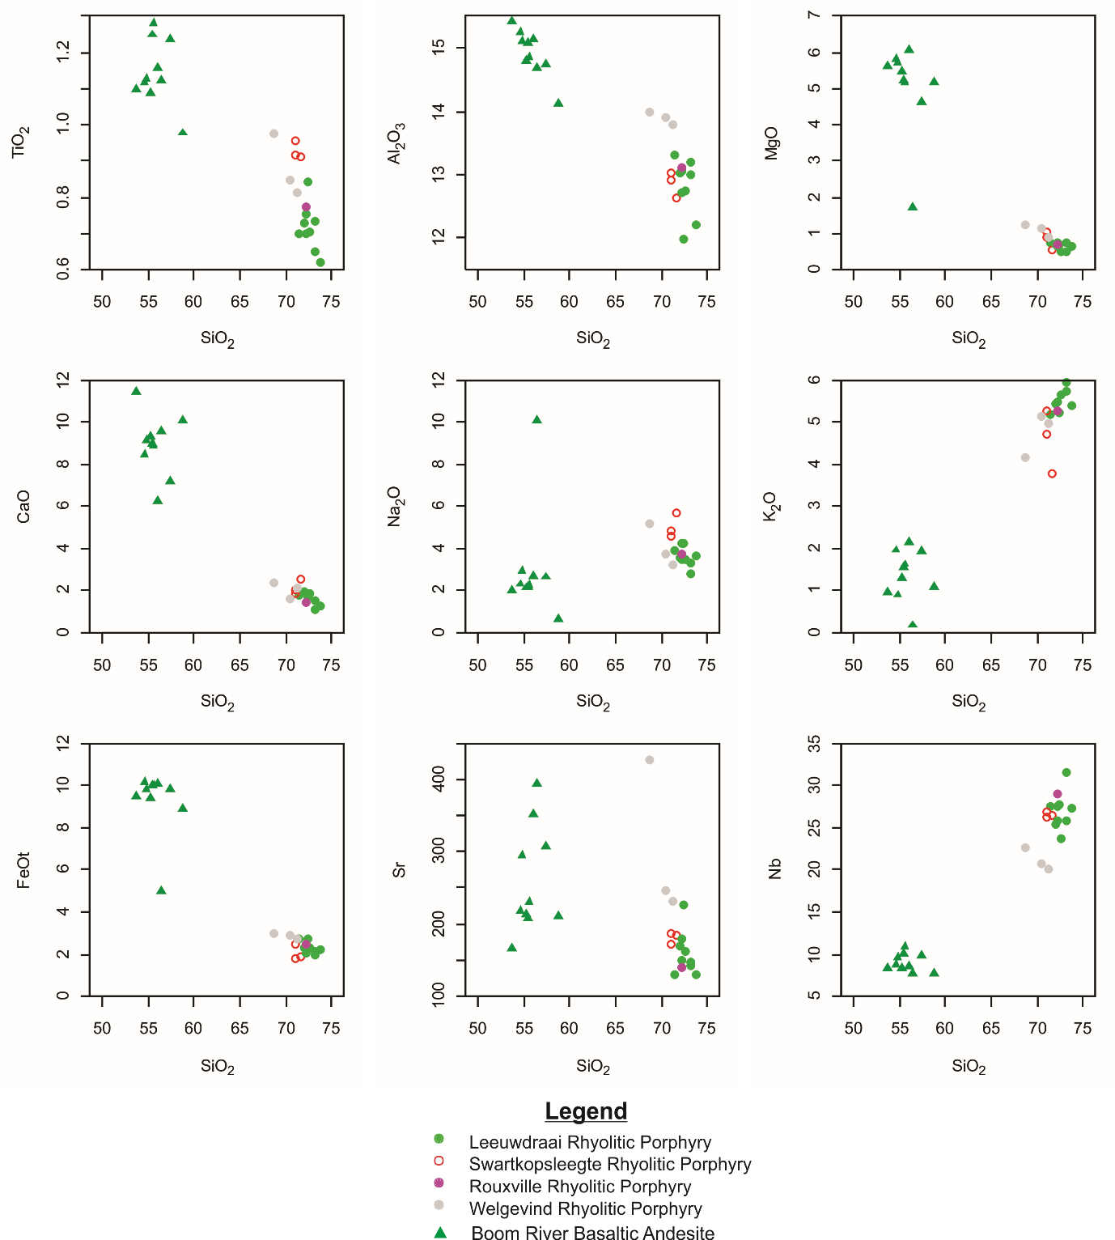
Figure S3. Harker plots for the Koras Group.

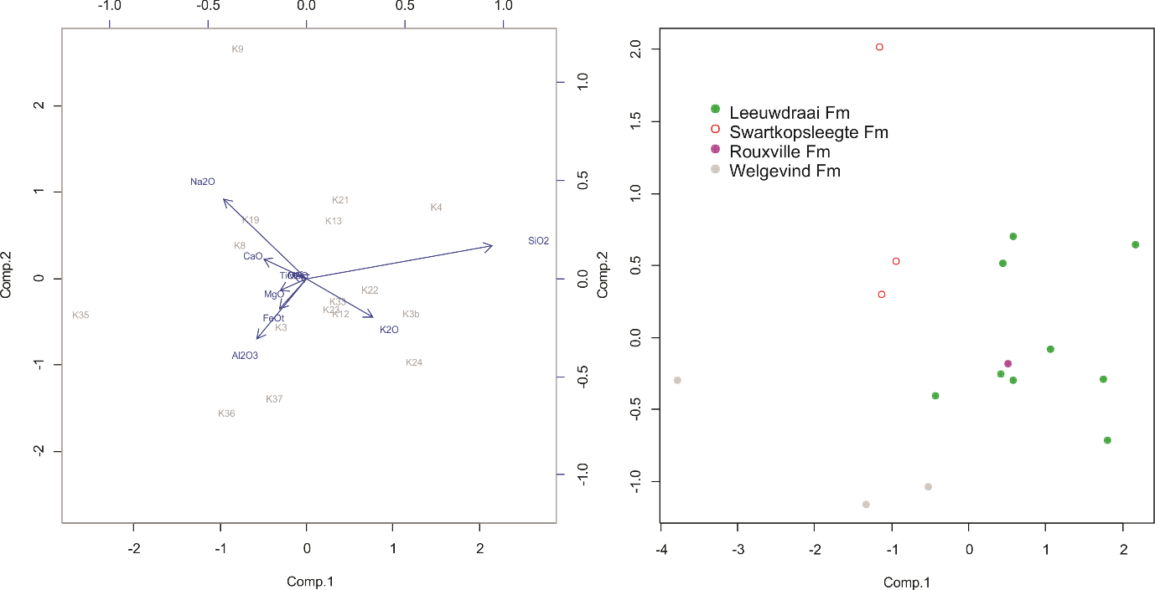
Figure S4. PCA plot for the Koras Group rhyolitic porphyries.

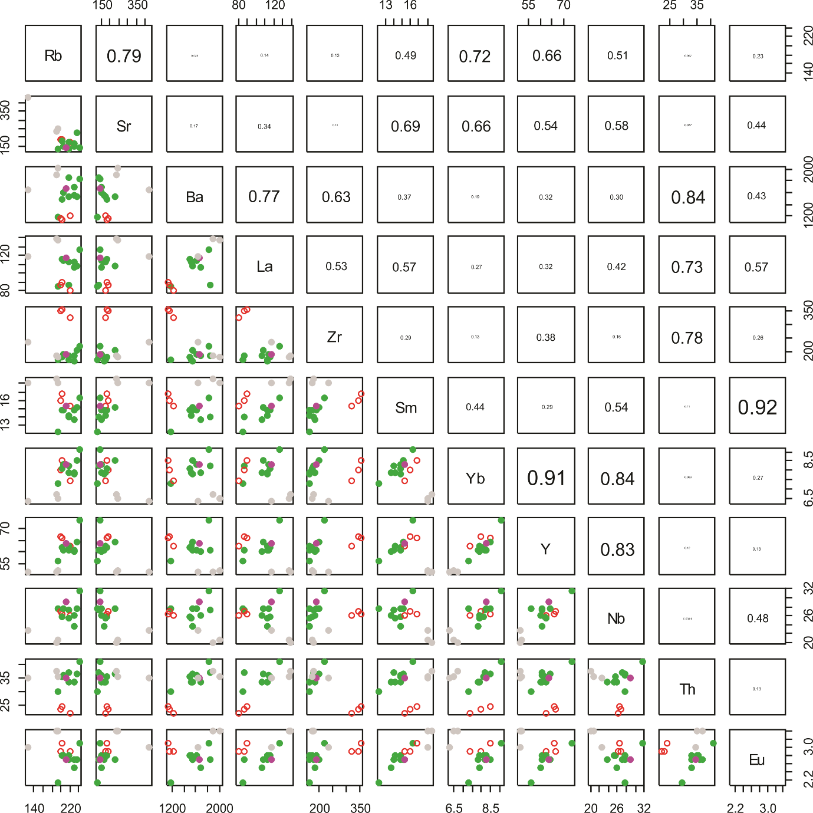
Figure S5. Trace element correlation plots for the Koras Group rhyolitic porphyries. Symbols are the same as for Fig. 7.

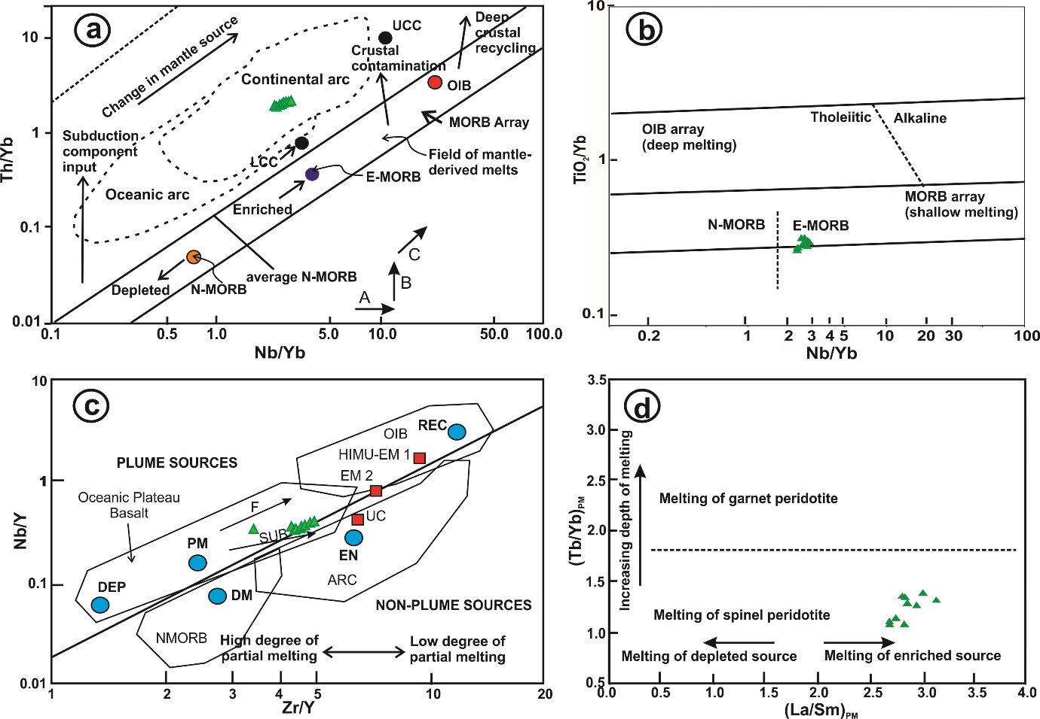
Figure S6. Trace element diagrams for mafic rocks with SiO₂ <55 wt.%. E-MORB. Enriched mid ocean ridge basalt, N-MORB: normal mid-ocean ridge basalt; OIB. ocean island basalt; PM. primitive mantle; VAT. volcanic arc tholeiite; WPB. within-plate basalt. (a) Nb/Yb-Th/Yb plot (after Pearce and Peate, 1995, Pearce et al., 1995) to distinguish the extent of crustal input; (b) Nb/Yb-TiO₂/Yb plot (after Pearce, 2008) to determine depth of melting; (c) Zr/Y-Nb/Y plot (after Fitton et al., 1997); (d) (La/Sm)_{PM}-(Th/Yb)_{PM} plot (after Khudoley et al., 2013); the spinel-garnet stability field boundary is after Wang et al. (2002). The PM subscript represents normalization to the primitive mantle values of McDonough et al. (1992). Crustal-contaminated samples are generally characterised by low (Tb/Yb)_{PM} values. The positions of PM, N-, E-MORB and OIB are plotted using the values of McDonough and Sun (1995). The three principal types of trend (vectors) that can cause variations shown in (a) are a horizontal trend (A) caused by melting of a variably enriched mantle wedge, a vertical trend (B) caused by a variable subduction component, and a positive sloping diagonal trend (C) caused by variable melt extraction (Pearce et al., 1995). For (c) arrows indicate the effects of batch melting (F) and subduction (SUB). Abbreviations in (c) are: UC. upper continental crust; PM. primitive mantle; DM. shallow depleted mantle; HIMU. high μ(U/Pb) source; EM1 and EM2. enriched mantle sources; ARC. arc-related basalts; NMORB. normal ocean ridge basalt; OIB. oceanic island basalt; DEP. deep depleted mantle; EN. enriched component; REC. recycled component.

REFERENCES CITED
Fitton, J. G., Saunders, A. D., Norry, M. J., et al., 1997. Thermal and Chemical Structure of the Iceland Plume. Earth and Planetary Science Letters, 153(3/4): 197–208. https://doi.org/10.1016/s0012-821x(97)00170-2
Khudoley, A. K., Prokopiev, A. V., Chamberlain, K. R., et al., 2013. Early Paleozoic Mafic Magmatic Events on the Eastern Margin of the Siberian Craton. Lithos, 174: 44–56. https://doi.org/10.1016/j.lithos.2012.08.008
Pearce, J. A., Peate, D. W., 1995. Tectonic Implications of the Composition of Volcanic ARC Magmas. Annual Review of Earth and Planetary Sciences, 23(1): 251–285. https://doi.org/10.1146/annurev.ea.23.050195.001343
Pearce, J. A., Baker, P. E., Harvey, P. K., et al., 1995. Geochemical Evidence for Subduction Fluxes, Mantle Melting and Fractional Crystallization beneath the South Sandwich Island Arc. Journal of Petrology, 36(4): 1073–1109. https://doi.org/10.1093/petrology/36.4.1073
Pearce, J. A., 2008. Geochemical Fingerprinting of Oceanic Basalts with Applications to Ophiolite Classification and the Search for Archean Oceanic Crust. Lithos, 100(1–4): 14–48. https://doi.org/10.1016/j.lithos.2007.06.016
Wang, K., Plank, T., Walker, J. D., et al., 2002. A Mantle Melting Profile across the Basin and Range, SW USA. Journal of Geophysical Research: Solid Earth, 107(B1): ECV5. https://doi.org/10.1029/2001jb000209
McDonough, W. F., Sun, S. S., Ringwood, A. E., et al., 1992. Potassium, Rubidium, and Cesium in the Earth and Moon and the Evolution of the Mantle of the Earth. Geochimica et Cosmochimica Acta, 56(3): 1001–1012. https://doi.org/10.1016/0016-7037(92)90043-i
McDonough, W. F., Sun, S. S., 1995. The Composition of the Earth. Chemical Geology, 120(3/4): 223–253. https://doi.org/10.1016/0009-2541(94)00140-4

