Supplementary materials

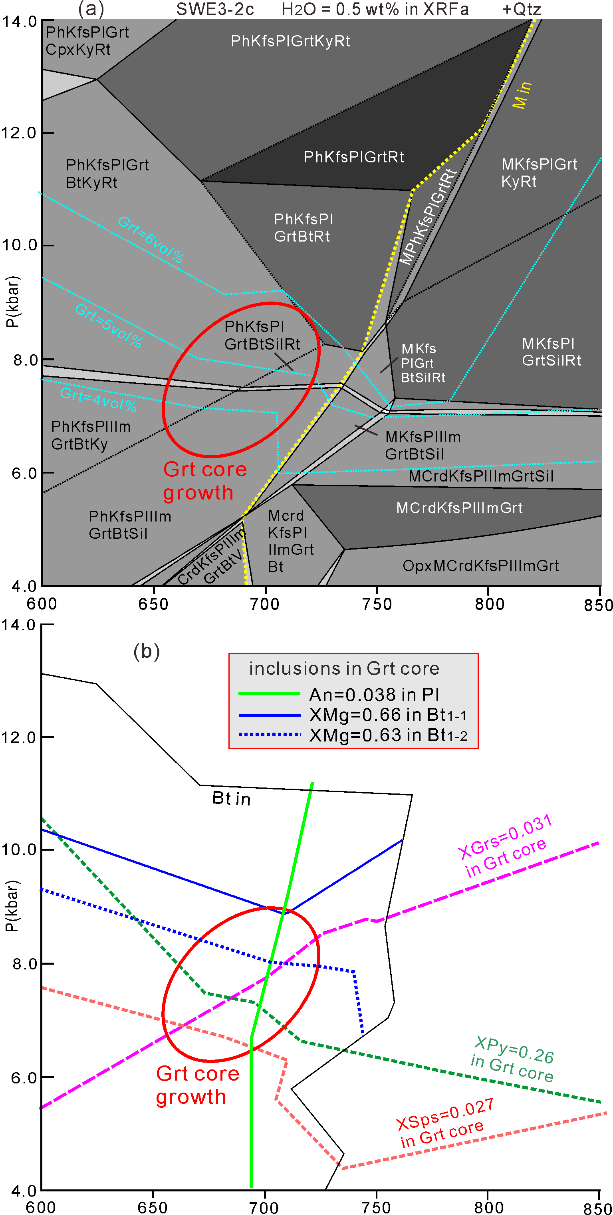

Figure S1. (a) P-T pseudosection for the bulk-rock composition XRF_{a} (Table 1) with isopleths for the modal content of garnet (light blue lines). The yellow line marks the solidus (M = melt). (b) Isopleths of Grs_{0.031}Sps_{0.027}Py_{0.28} (garnet core), XMg (0.63, 0.66) in Bt₁, and XAn (0.038) in plagioclase. The red ellipsis comprises intersections of these isopleths and, thus, possible P-T conditions for the formation of the garnet core. Mineral abbreviations as in the text.

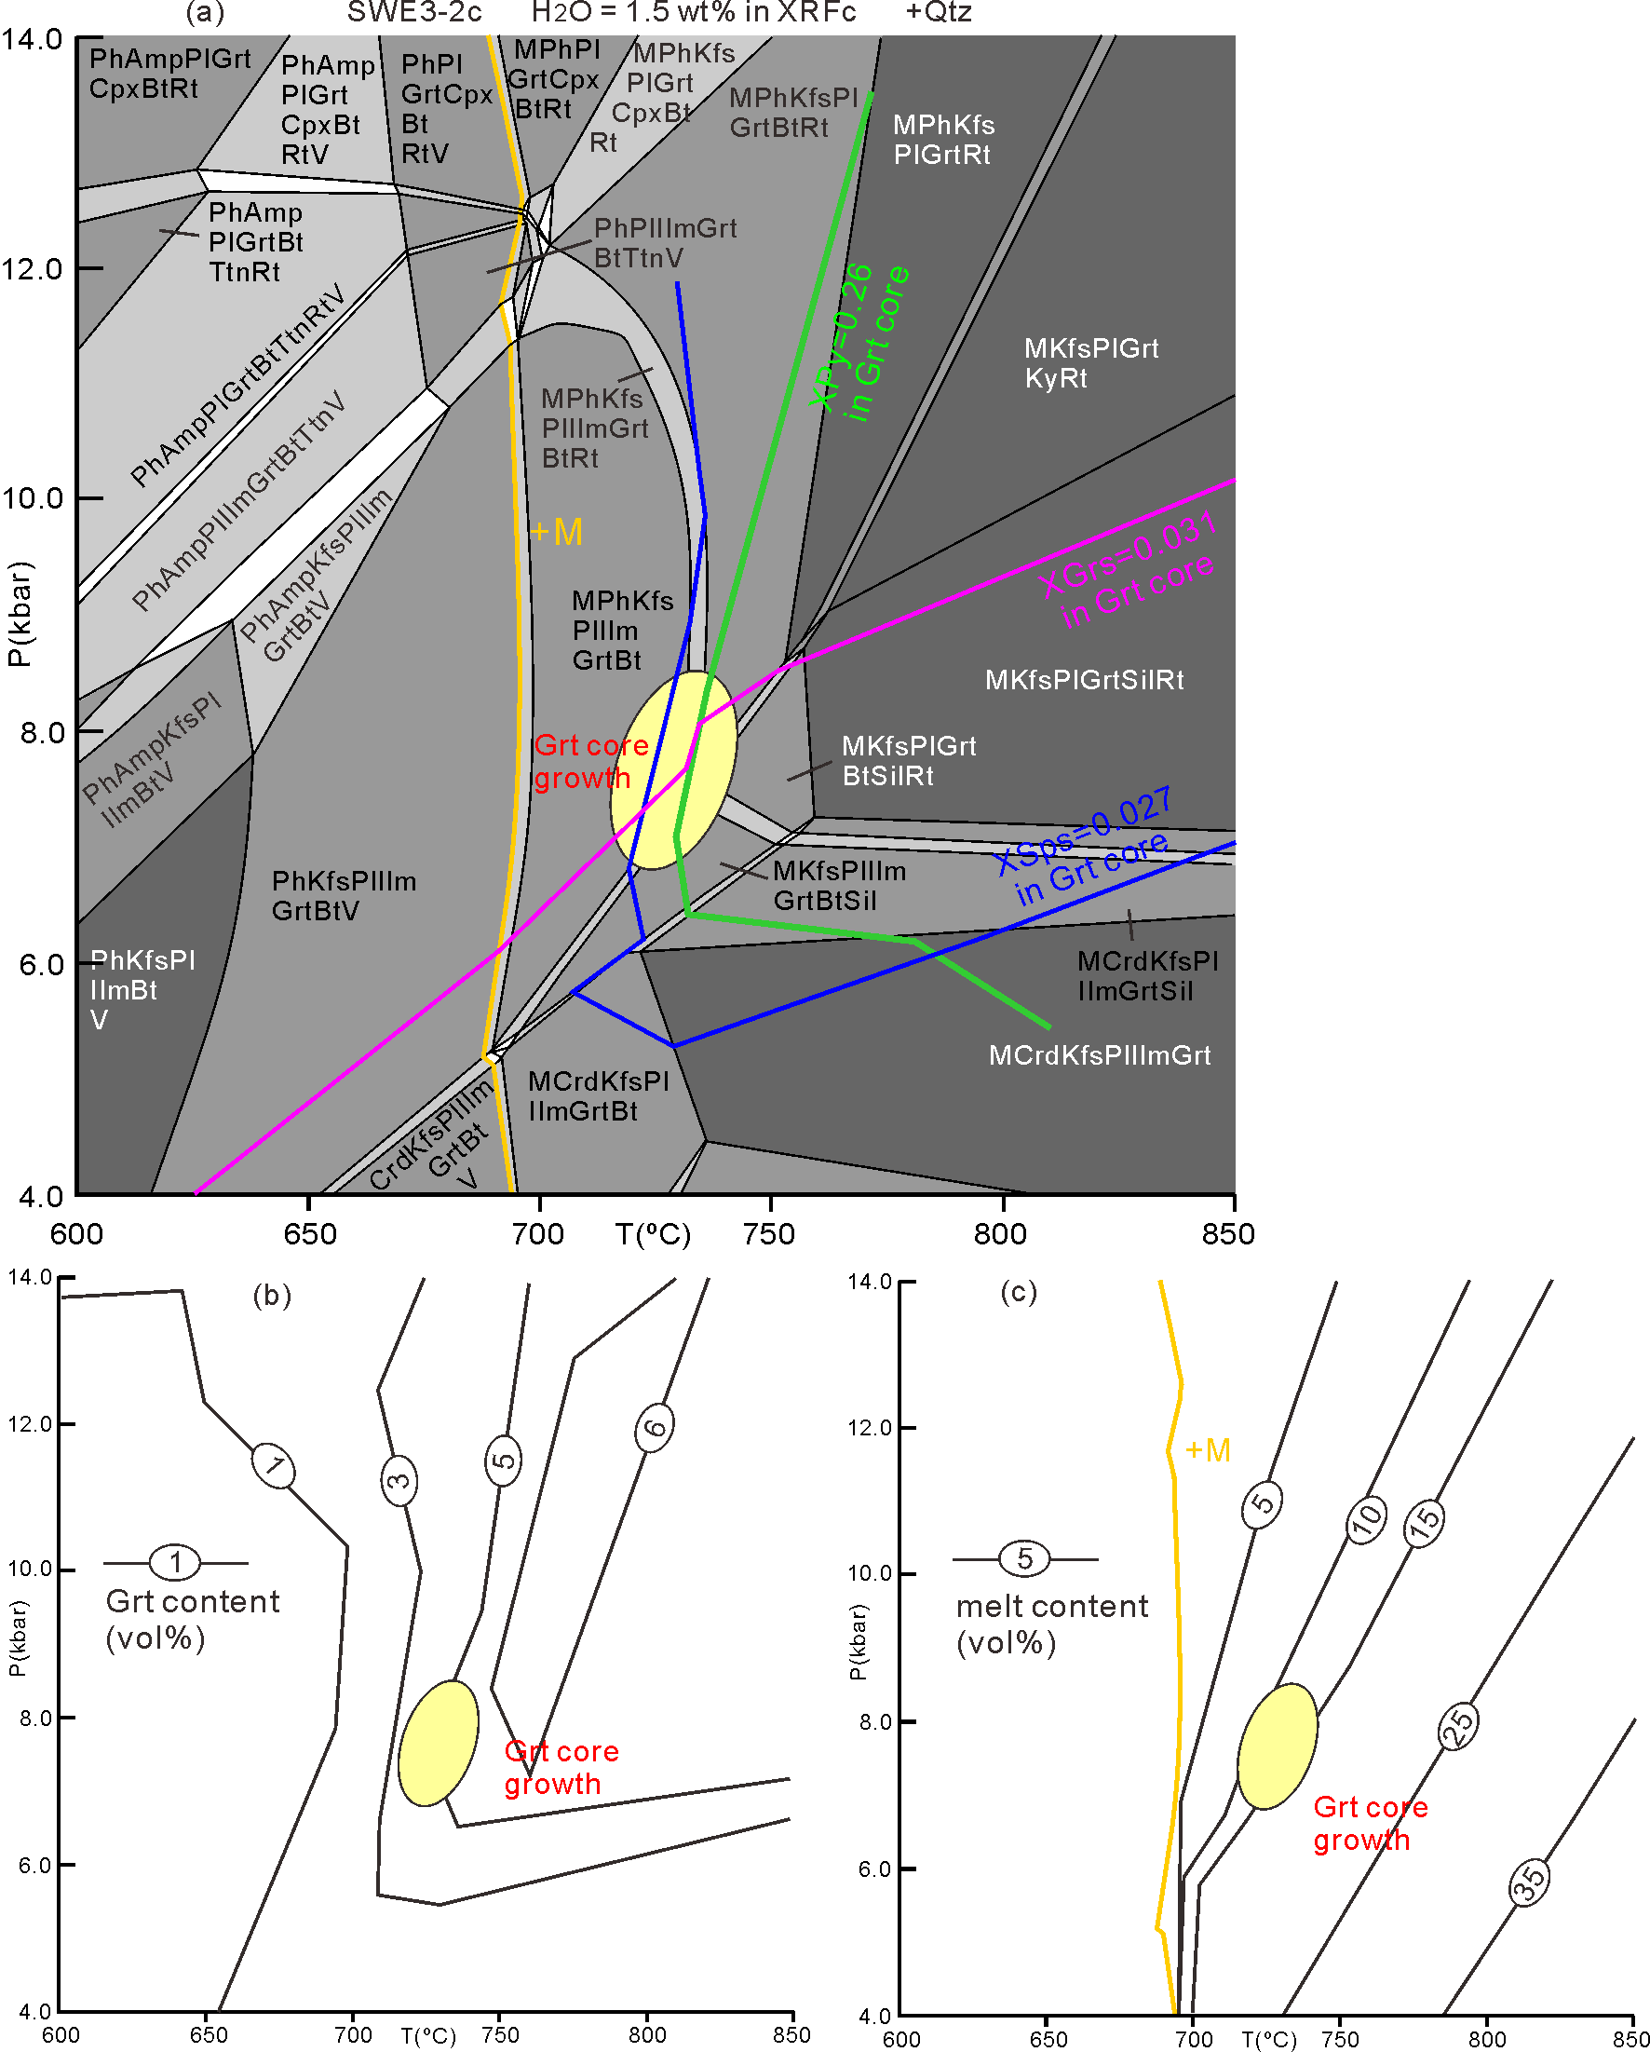

Figure S2. (a) P-T pseudosection for bulk-rock compositions XRF_{c} (Table 1) and isopleths of Grs_{0.031}Sps_{0.027}Py_{0.28} (garnet core) to define P-T conditions of stage I (yellowish ellipsis). (b, c) Isopleths for modal contents of garnet and melt. The red ellipsis comprises possible P-T conditions for the formation of the garnet core. Mineral abbreviations as in the text.

